JIM PREPARATORY NURSERY AND PRIMARY SCHOOL - IKIKI BUDAKA

MOTTO: OUR GOD IS ABLE

Email: [jimpreparatoryps@gmail.com](mailto:jimpreparatoryps@gmail.com)

**PRIMARY FOUR END OF TERM ONE EXAM 2024**

**MATHEMATICS**

**TIME ALLOWED: 2 HOURS 30 MINUTES**

NAME:............................................................................ STREAM:.....................................................

**SECTION: A (40 marks)**

1. Add :

T O

3 1

+ 4

2. Complete;

97 = ___ tens + ____ones

3. Name the set below.

     

______________________

4. Write the number after,

312 , ___

5. Subtract ;

4 7 tins

* 1 2 tins

6. What is the place value of 8 in 780?

____________

7. Write 34 in words;

__________________

8. Multiply ;

3 × 2 = ___

9. Write the number shown on the abacus.

H T O

10. Write the number between.

65, ____ 67

11. Find the sum;

H T O

7 5 1

+ 1 3 7

12. Show 3 O’clock on the clockface below.

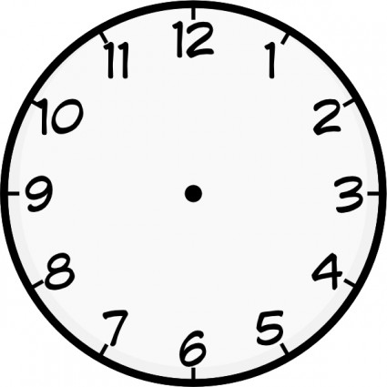

13. Subtract 2 from 5 .

14. Write the total in figures.

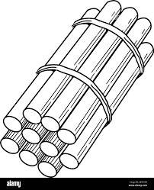  ____

+

=

+

10 10

15. Find the missing number

1, 4, 7, _____

16. Name the shape below.

____________

17. Write in figures.

a half

18. Arrange the numbers beginning with the smallest.

17, 47, 7, 27

____, ____, ____, ____

19. Share 9 sweets equally among 3 boys.

How many sweets does each boy get?

20. Work out;

- 2 = 4

**SECTION B (60 marks)**

21. (a) How many months are in a year?

____________

(b) Write the number of days in the months below.

(i) January __________

(ii) February __________

(iii) March ___________

22. (a) Shaded $\frac{1}{3}$

|  |  |  |
| --- | --- | --- |
|  |  |  |

(b) Name the fraction

_________

(c) Work out ;

=

23. Complete;

____

---0 1 2 3 4 5 6 7 8 9 10 ---

____

____ - ___ = ___

24. Work out ;

(a) Peter has 215 hens and John has 20 hens. How many

hens do they have altogether?

(b) A class has 77 pupils. 5 pupils are absent. How many

pupils are present?

(c) There are 8 pencils in each tin. How many pencils are

there in 2 similar tins?

25. (a) Find the missing number.

___

7

__

2 __

4

10

5

___

26. **Study the diagram below and answer the questions**

**that follow.**

**Tree N**

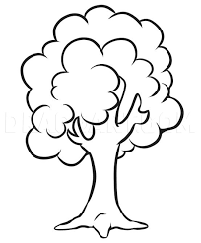 

10 metres

6 metres

**Tree M**

1. Which tree is shorter?

____________

1. How tall is tree N?

___________

(c) Add ;

1. 0 metres

+ 6 metres

27. Work out;

(a) H T O

6 5 2

- 1 4 2

(b) 3

× 4

(c) H T O

3 1 5

+ 3 2

28. **Study the sets below and use them to answer the**

**questions that follow.**

Set A Set B

 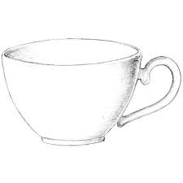

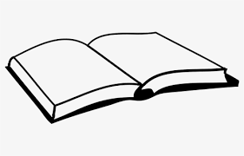 

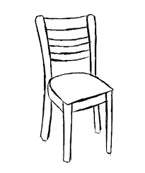

 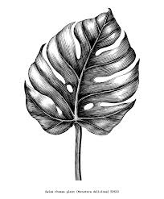

1. How many members are in set A?
2. List the common members of set A and Set B.

Common members = { }

1. Use “less” or “more”.

Set A has __________members than set B.

29. Name the shapes

|  |  |  |
| --- | --- | --- |
|  |  |  |
|  |  |  |

30. Find the missing number.

(a) 7, 9, 11 , _____

(b) 16, 12, 8 , _____

31. The price list

|  |  |
| --- | --- |
| Item | Cost |
| a sweet | Sh. 200 |
| a comb | Sh. 300 |
| a tooth brush | Sh. 600 |

1. How many items are on the price list?
2. What is the cost of a sweet?
3. Add;

Sh. 300

+ sh. 600

32. Use the graph to answer the questions that follow.

|  |  |  |  |
| --- | --- | --- | --- |
| Easter Egg Drawing - Drawing Skill  Easter Egg Drawing - Drawing Skill  Easter Egg Drawing - Drawing Skill  Easter Egg Drawing - Drawing Skill | Easter Egg Drawing - Drawing Skill  Easter Egg Drawing - Drawing Skill  Easter Egg Drawing - Drawing Skill | Easter Egg Drawing - Drawing Skill  Easter Egg Drawing - Drawing Skill  Easter Egg Drawing - Drawing Skill  Easter Egg Drawing - Drawing Skill  Easter Egg Drawing - Drawing Skill | Easter Egg Drawing - Drawing Skill |

Ann Noel Sophia Teta

(a) How many people have eggs?

(b) Who has only one egg?

(c) Count and write the total number of eggs all the

people have.

**End**